WEEK 3 – ASP.NET Core 8.0 Web API

Submitted By: Priyanshu Shekhar
Superset ID: 8011160
College: C. V. Raman Global University, Odisha
Registration No.: 2301020267
Email: shekharpriyanshu21@gmail.com

Exercise-1: Create a Web API with GET & POST

Code:
using Microsoft.AspNetCore.Mvc; using System.Collections.Generic;
namespace WebApiDemo.Controllers
{
[ApiController] [Route("[controller]")]
public class ValuesController : ControllerBase
{
private static List<string> values = new() { "value1", "value2" };

[HttpGet]
public IEnumerable<string> Get() => values;

[HttpPost]
public IActionResult Post([FromBody] string value)
{
values.Add(value); return Ok(values);
}
}
}

Output:

//GET/Values
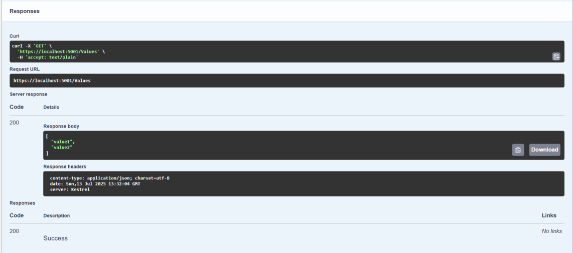

//POST/Values

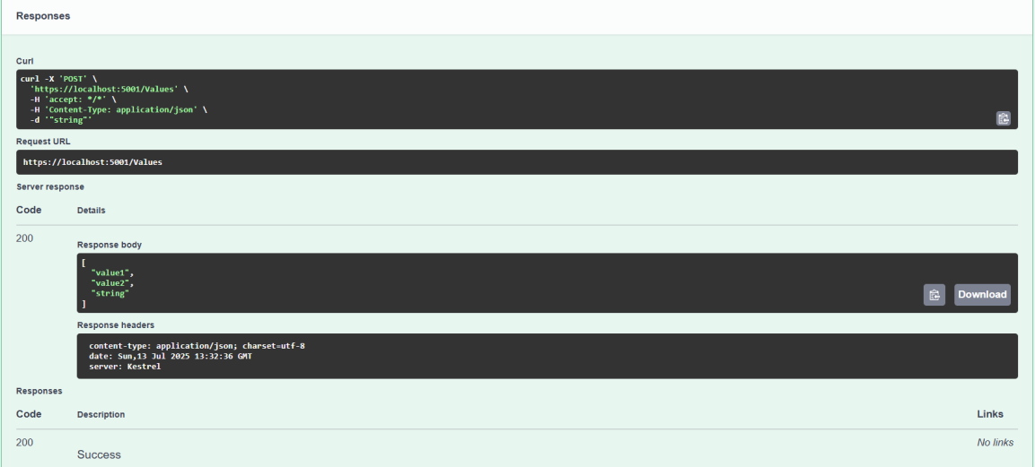

Exercise-2: Enable Swagger in Web API

Code:
using Microsoft.AspNetCore.Authentication.JwtBearer; using Microsoft.IdentityModel.Tokens;
using Microsoft.OpenApi.Models; using System.Text;
using WebApiDemo.Filters;

var builder = WebApplication.CreateBuilder(args);

builder.Services.AddControllers(); builder.Services.AddEndpointsApiExplorer();

builder.Services.AddSwaggerGen(c =>
{
c.SwaggerDoc("v1", new OpenApiInfo { Title = "WebApiDemo", Version = "v1" });

c.AddSecurityDefinition("Bearer", new OpenApiSecurityScheme
{
Description = @"JWT Authorization header using the Bearer scheme.
Enter 'Bearer' followed by your token. Example: Bearer eyJhbGciOiJIUzI1...",
Name = "Authorization",
In = ParameterLocation.Header,
Type = SecuritySchemeType.ApiKey, Scheme = "Bearer"
});

c.AddSecurityRequirement(new OpenApiSecurityRequirement
{
{
new OpenApiSecurityScheme
{
Reference = new OpenApiReference
{
Type = ReferenceType.SecurityScheme, Id = "Bearer"
},
Scheme = "oauth2", Name = "Bearer",
In = ParameterLocation.Header,
},
new List<string>()
}
});
});

var key = Encoding.ASCII.GetBytes("mysuperdupersecret"); builder.Services.AddAuthentication(JwtBearerDefaults.AuthenticationScheme)

.AddJwtBearer(options =>
{
options.TokenValidationParameters = new TokenValidationParameters
{
ValidateIssuer = true, ValidateAudience = true, ValidateLifetime = true, ValidateIssuerSigningKey = true, ValidIssuer = "mySystem", ValidAudience = "myUsers",
IssuerSigningKey = new SymmetricSecurityKey(key)
};
});

builder.Services.AddScoped<CustomAuthFilter>(); var app = builder.Build();
app.UseSwagger(); app.UseSwaggerUI();

app.UseHttpsRedirection();

app.UseAuthentication(); app.UseAuthorization();
app.MapControllers(); app.Run();

Output:
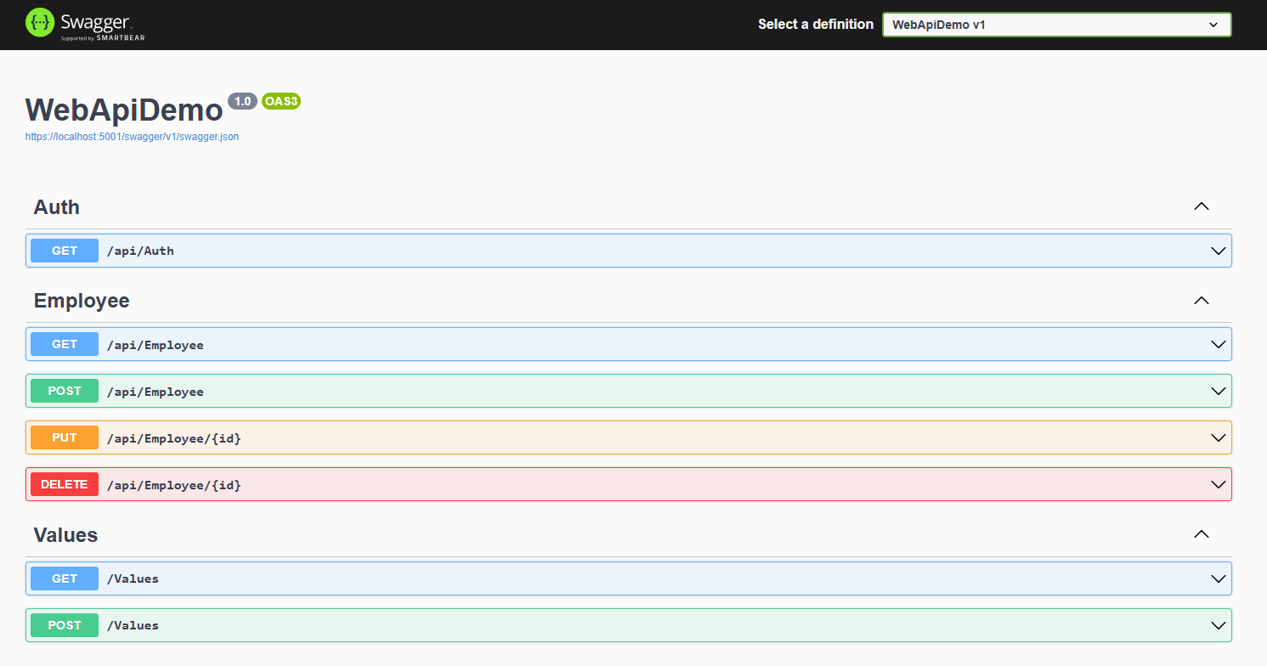

Exercise-3: Create Model & Custom Filter

Code:

//Models/Employee.cs
using System;
using System.Collections.Generic;

namespace WebApiDemo.Models
{

public class Skill { public string SkillName { get; set; } }
public class Department { public string DeptName { get; set; } }

public class Employee
{
public int Id { get; set; }
public string Name { get; set; } public int Salary { get; set; } public bool Permanent { get; set; }
public Department Department { get; set; } public List<Skill> Skills { get; set; } public DateTime DateOfBirth { get; set; }
}
}

//Filters/CustomAuthFilter.cs
using Microsoft.AspNetCore.Mvc;
using Microsoft.AspNetCore.Mvc.Filters;
namespace WebApiDemo.Filters
{
public class CustomAuthFilter : ActionFilterAttribute
{
public override void OnActionExecuting(ActionExecutingContext context)
{
if (!context.HttpContext.Request.Headers.TryGetValue("Authorization", out var token) ||
!token.ToString().Contains("Bearer"))
{
context.Result = new BadRequestObjectResult("Invalid request - No Auth token or Bearer missing");
}
}
}
}

Output:
//Unauthorize (Status Code: 401)
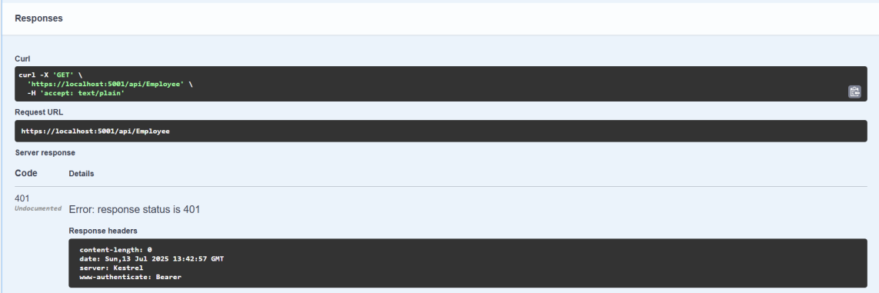

//Authorize (Status Code: 200)

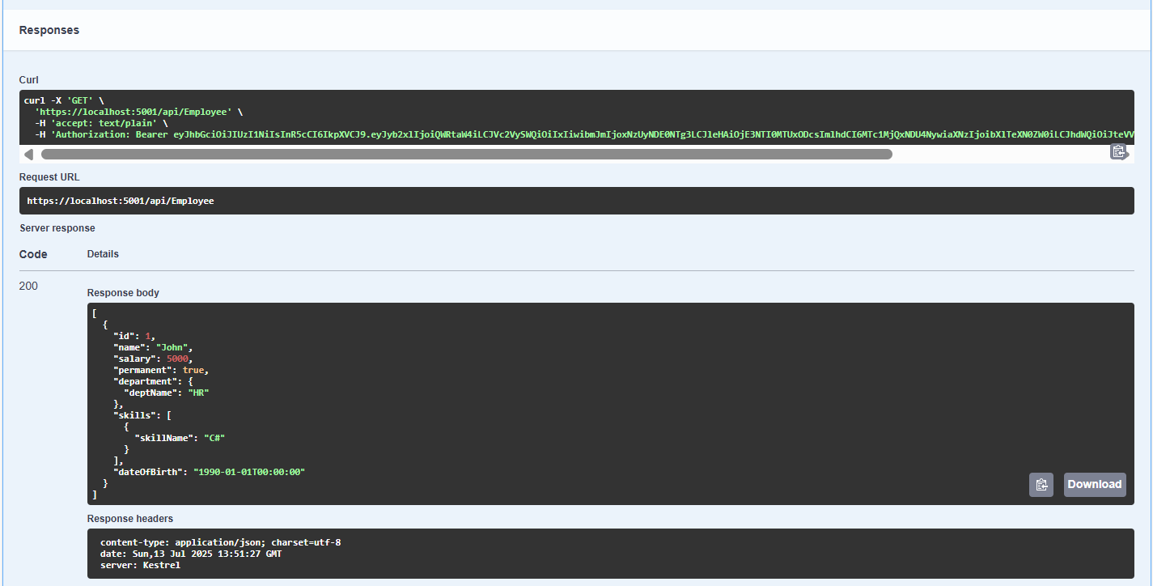

Exercise-4: Add PUT & DELETE for Employee API

Code:
using Microsoft.AspNetCore.Mvc;
using Microsoft.AspNetCore.Authorization; using WebApiDemo.Models;
using System.Collections.Generic; using System.Linq;
using System;

namespace WebApiDemo.Controllers
{
[ApiController] [Route("api/[controller]")] [Authorize(Roles = "Admin")]
public class EmployeeController : ControllerBase
{
private static List<Employee> employees = new()
{
new Employee
{
Id = 1,
Name = "John", Salary = 5000, Permanent = true,
Department = new Department { DeptName = "HR" },
Skills = new List<Skill> { new Skill { SkillName = "C#" } }, DateOfBirth = new DateTime(1990, 1, 1)
}
};

[HttpGet]
public ActionResult<List<Employee>> Get() => employees;

[HttpPost]
public IActionResult Post([FromBody] Employee emp)
{
employees.Add(emp); return Ok(emp);
}

[HttpPut("{id}")]
public IActionResult Put(int id, [FromBody] Employee emp)
{
if (id <= 0)
return BadRequest("Invalid employee id");

var existing = employees.FirstOrDefault(e => e.Id == id);

if (existing == null)
return BadRequest("Invalid employee id");

existing.Name = emp.Name; return Ok(existing);
}
[HttpDelete("{id}")]
public IActionResult Delete(int id)
{
var existing = employees.FirstOrDefault(e => e.Id == id); if (existing == null)
return NotFound();

employees.Remove(existing); return NoContent();
}
}
}

Output:

//PUT/api/Employee/{id}
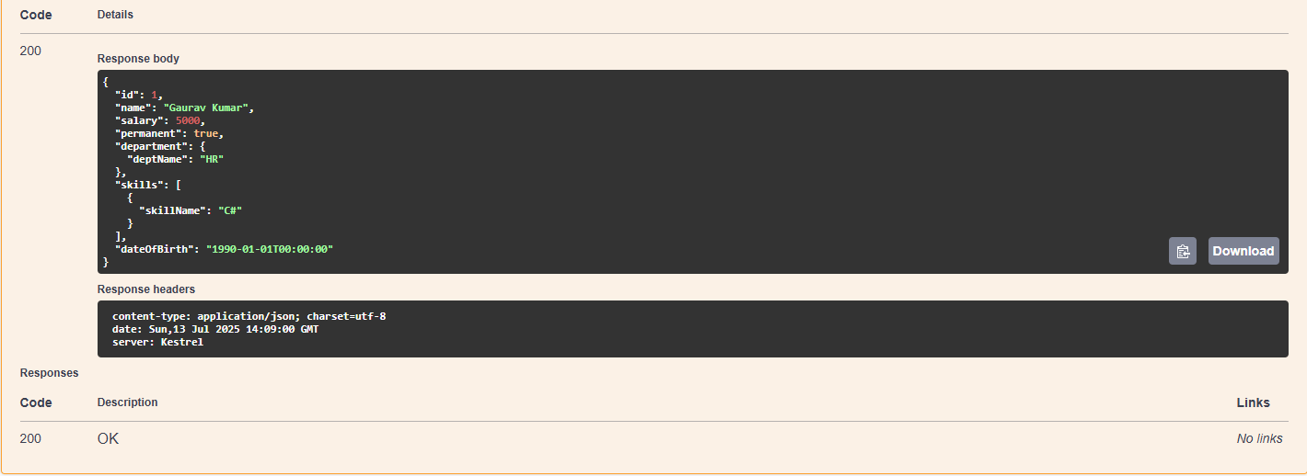

//DELETE/api/Employee/{id}
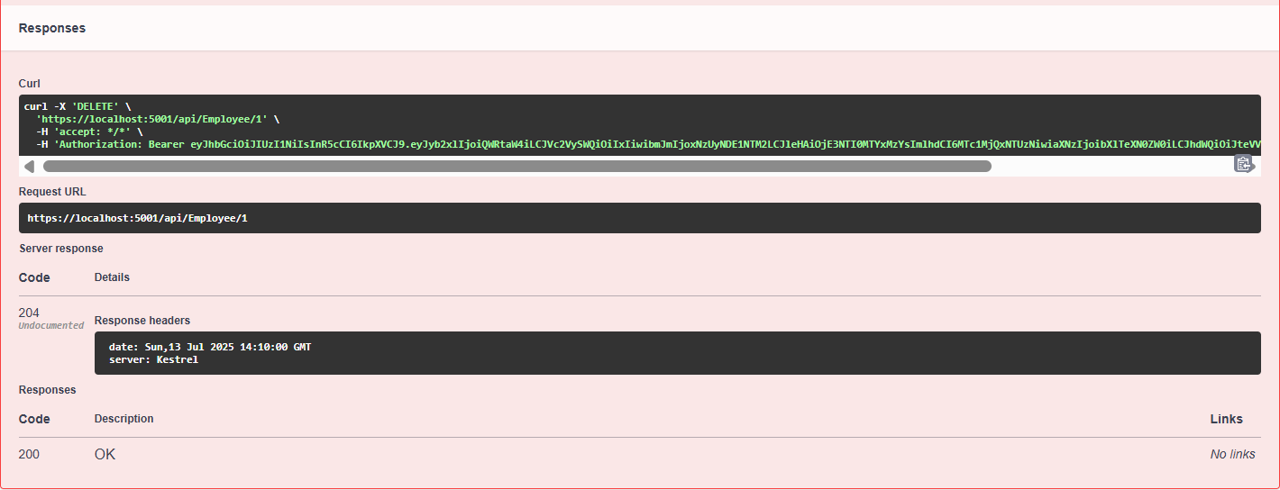

Exercise-5: Implement JWT Token Authentication

Code:
using Microsoft.AspNetCore.Mvc;
using Microsoft.AspNetCore.Authorization; using Microsoft.IdentityModel.Tokens; using System.Text;
using System.IdentityModel.Tokens.Jwt; using System.Security.Claims;

using System;

namespace WebApiDemo.Controllers
{
[ApiController] [Route("api/[controller]")] [AllowAnonymous]
public class AuthController : ControllerBase
{
[HttpGet]
public string GetToken()
{
var key = Encoding.ASCII.GetBytes("mysuperdupersecret"); var tokenHandler = new JwtSecurityTokenHandler();
var tokenDescriptor = new SecurityTokenDescriptor
{
Subject = new ClaimsIdentity(new[]
{
new Claim(ClaimTypes.Role, "Admin"), new Claim("UserId", "1")
}),
Expires = DateTime.UtcNow.AddMinutes(10), Issuer = "mySystem",
Audience = "myUsers",
SigningCredentials = new SigningCredentials(new SymmetricSecurityKey(key), SecurityAlgorithms.HmacSha256Signature)
};
var token = tokenHandler.CreateToken(tokenDescriptor); return tokenHandler.WriteToken(token);
}
}
}

Output:

//Token Generation
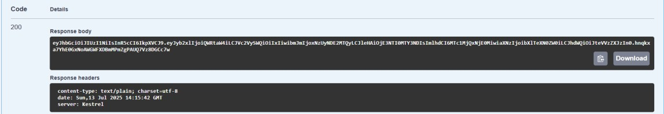

//Authorization

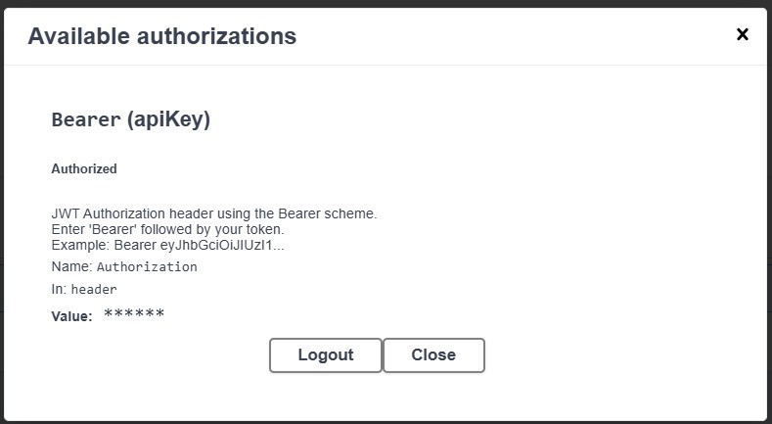

Exercise-6: Kafka Producer and Consumer

Code:

//Kafka/KafkaProducer.cs
using Confluent.Kafka; using System;
using System.Threading.Tasks;
namespace WebApiDemo.Kafka
{
public class KafkaProducer
{
public static async Task Produce(string topic, string message)
{
var config = new ProducerConfig { BootstrapServers = "localhost:9092" };

using var producer = new ProducerBuilder<Null, string>(config).Build();
var result = await producer.ProduceAsync(topic, new Message<Null, string> { Value = message }); Console.WriteLine($"Delivered to: {result.TopicPartitionOffset}");
}
}
}

//Kafka/KafkaConsumers.cs
using Confluent.Kafka; using System;
using System.Threading;
namespace WebApiDemo.Kafka
{
public class KafkaConsumer
{
public static void Consume(string topic)
{
var config = new ConsumerConfig
{
BootstrapServers = "localhost:9092", GroupId = "test-consumer-group", AutoOffsetReset = AutoOffsetReset.Earliest
};
using var consumer = new ConsumerBuilder<Ignore, string>(config).Build(); consumer.Subscribe(topic);

CancellationTokenSource cts = new CancellationTokenSource(); try
{
while (true)
{
var cr = consumer.Consume(cts.Token); Console.WriteLine($"Consumed message: {cr.Value}");
}
}
catch (OperationCanceledException)
{
consumer.Close();
}
}
}
}

Output:

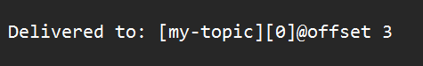
//Producer

//Consumer

